The Yare & Bure One Design (YBOD)
Construction and measurement rules (revised 2023)
Part 1. Sails, rigging and spars pages 2, 3, 4, 5
Part 2. Common Specification pages 6,7, 8, 9, 10
Part 3. Wooden hulls and decks page 11
Part 4. GRP hulls and decks page 12
Part 5. Colours page 13
Part 6. General dimensions page 14
Part 7. Scrutineering page 15
The following 'Rules' have been designed to give the builder or owner a concise and
definitive set of measurements and instructions to aid the maintenance or construction of the 1908 Yare & Bure half-decked one design by Ernest Woods, known colloquially as the 'White Boat'.

With the enforcement of these rules, the class aims to ensure that all existing and all new-build YBODs conform to the same measurements, regulations, standards and restrictions as every other, giving no YBOD either an advantage or disadvantage over any other.

Please note that fittings, coatings, setups etc. which are not specifically mentioned should not be automatically considered either in, nor out of class, it is therefore recommended that in any case of uncertainty a scrutineer be contacted to provide advice, guidance and clarification.

In the majority of cases a pattern or sample may be available if required.

Whilst every care has been taken to ensure accuracy it is possible that mistakes remain so check before you cut or drill anything expensive.

The class accepts no liability so please be vigilant.

Part 1: Sails, Rigging and Spars.

- Permitted sails consist only of:
  - A mainsail
  - A jib
  - A storm jib

As detailed in The Sail Plan (page 3) and shall only be made by the Official Sailmaker,
Jeckells, Station Road, Hoveton.

- White sails only are allowed, and the only insignia etc. to be affixed to the sails are the sail numbers and a logo of the Official Sailmaker in each case complying and positioned in accordance with the ISAF Racing Rules of Sailing.

- All sails made after the adoption of these Rules shall be made to the measurements/specifications.

- The sail Measurer may at his discretion or at the direction of the Committee require any YBOD sail (whether new or not) to be measured to ascertain whether it is in compliance with these Rules.

- All rigging shall be in accordance with Common Rigging (page 4) Permitted spars consist only of:
  - Mast
  - Gaff
  - Boom
  - Bowsprit
As detailed in Spars (page 5)

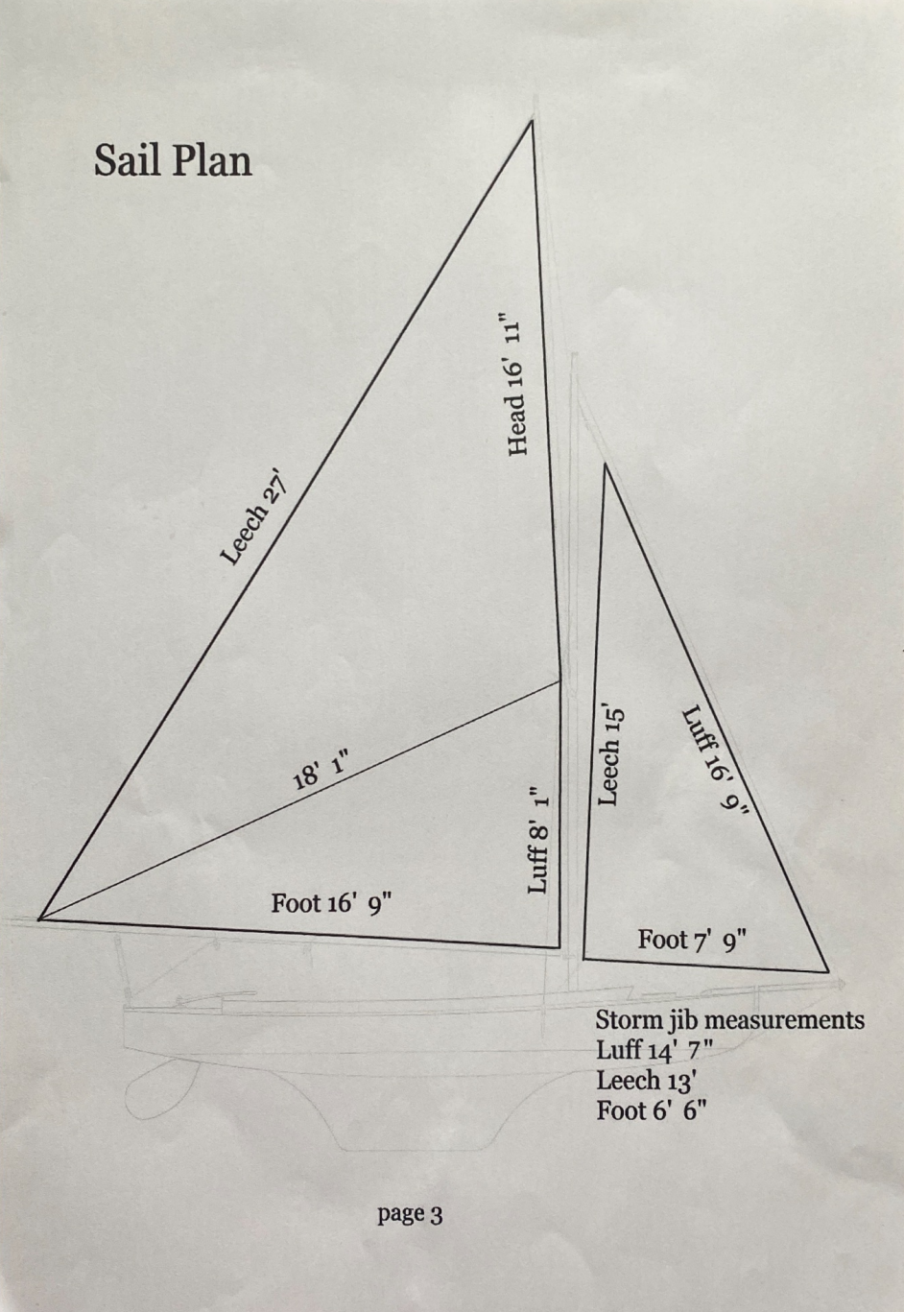

Common Rigging.
All Common Rigging items are mandatory unless an option is indicated.
Shrouds; min. 4mm 7x7 or 1 x 16 stainless steel or galvanised wire rope, soft eye at top, rigging screw or thimble and lacing at chain plate.

Forestay; min. 4mm 7 x 7 or 1 x 16 stainless steel or galvanised wire rope, with min. 6mm polyester (or similar) rope tail.

Throat halyard; min. 4mm 7x7 or 1 x 16 stainless steel or galvanised wire rope, with min. 8mm polyester (or similar) rope downhaul arranged with a purchase.
As an option the rope downhaul may be augmented with a 7:1 purchase with a separate block and tackle capable of adjustment whilst sailing,.

Peak halyard; min. 4mm 7x7 or 1 x 16 stainless steel or galvanised wire rope, with min. 8mm polyester (or similar) rope downhaul arranged with a purchase not exceeding 2:1.

Gaff span; min. 4mm 7x7 or 1 x 16 stainless steel or galvanised wire rope. Allow for 3 reefs.

Throat bridle; min. 4mm 7x7 or 1 x 16 stainless steel or galvanised wire rope.

Bobstay; min 5mm 7 x 7 or 1 x 16 stainless steel or galvanised wire rope, rigging screw, swage eye, thimble, lacing or shackle.

Jib halyard; min 8mm polyester (or similar).
one end fixed to hound and arranged with a purchase not exceeding 2:1.

Jib sheets; min 8mm polyester (or similar) rope predominantly white, coloured flecks are permitted a purchase of 2:1 is optional.
ratchet blocks and jamming cleats are optional.

Jib outhaul; min 5mm stainless steel or galvanised wire rope, with a polyester (or similar) rope tail (optional)or a fixed eye. It will be 28 ½ “ from the gammon iron.

Mainsheet; min 8mm polyester (or similar) rope predominantly white, coloured flecks are permitted a ratchet block is a permitted option.

Topping lift; min 8mm polyester (or similar) rope with a 4mm tail passing through both lower hound sheaves a purchase is optional.

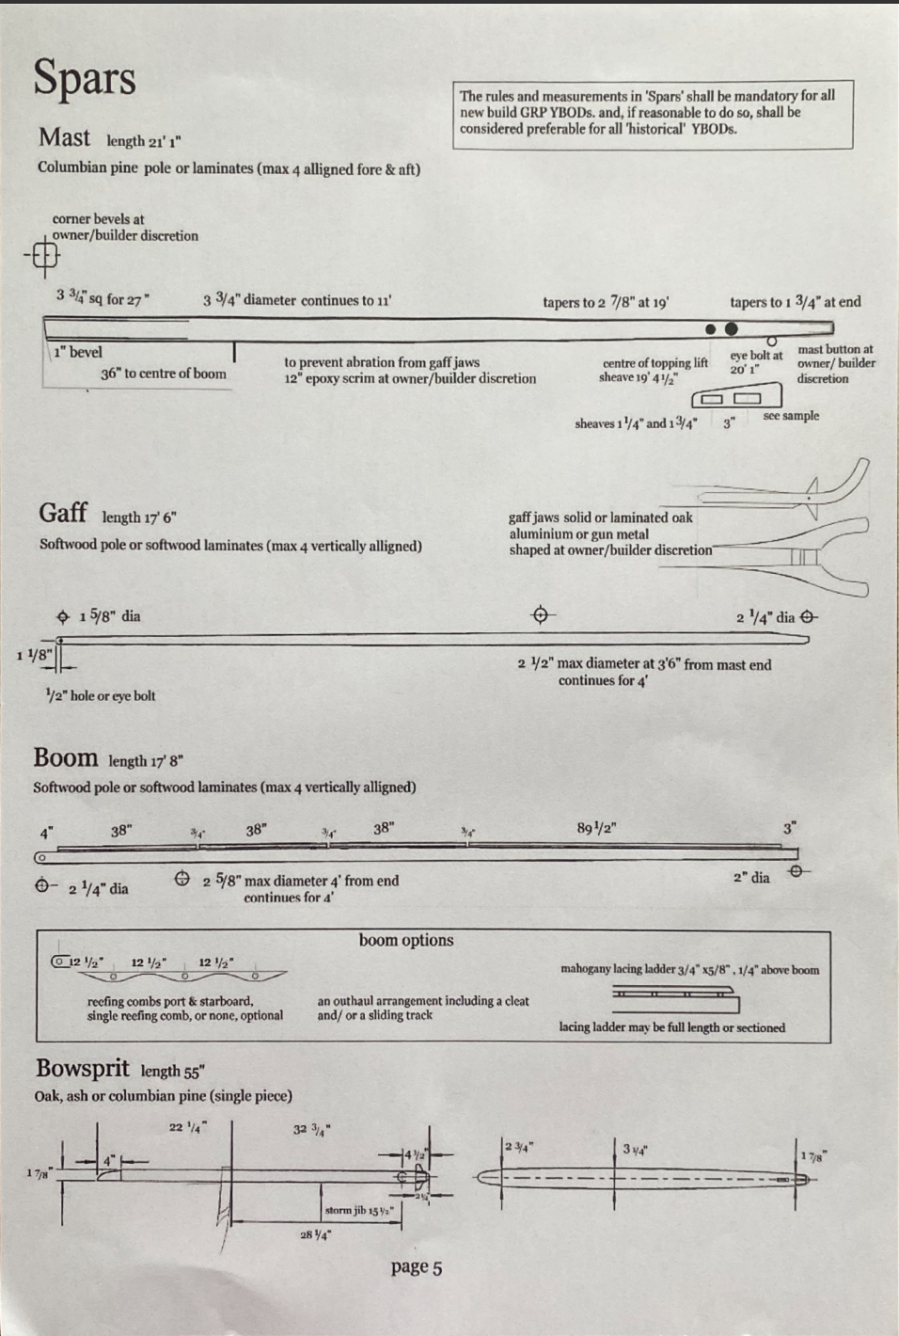Part 2: Common Specification (structural and furniture)
The items listed in Common Specification shall be deemed mandatory unless an option is indicated.
Ballast keel; solid lead cast from the class pattern, finished weight shall be 178.2 kg + or - 4kg.
Keel bolts; 3 x 20mm stainless steel or wrought iron and 2 x 8mm stainless steel or wrought iron (not necessary for GRP stub).
Rudder; 5/32" or 4mm galvanised mild steel or stainless steel with 1" shaft as class pattern.
Rudder tube; galvanised iron, stainless steel or GRP tube 1 5/16" external diam. and 1 1/16" internal diam. or metric equivalents.
Bowsprit cap; bronze, chromed bronze or stainless steel.

Gammon iron; all galvanised or stainless steel.
Heel iron; [front face 18 1/4" from stem]
Gooseneck;
Chain plates; [90" from stem]
Mainsheet [3" from aft edge of transom] this does vary widely.
horse;

Tiller; galvanised iron, bronze or chromed bronze shaped as class pattern
Rudder deck bronze, chromed bronze or stainless steel (builders name and build date etc.
Plate and may be engraved into deck plate but the wording must be approved by the
Collar; class).
Rigging screw; bodies bronze, chromed bronze or stainless steel.

Jib fairleads; [11/4" aft of main beam and 4" from coaming. non adjustable]
Burgee/ A burgee may be flown on either or both of the masthead or the end of the gaff.
Wind
indicator: A wind indicator may be fitted at the masthead only.
Whisker
pole: Shall be made of timber fitted with a yoke at one end and a metal spike at the other and shall be no longer than 2.5m such measurement to be taken from the point where the yoke or pole will touch the mast but not to include any visible part of the spike (i.e. between bearing surfaces). As an option a small rope loop may be added to the clew of jib into which the spike may be threaded when the whisker pole is used.

Common Specification (continued)

Mooring eye/s, bobstay bolt, locker catches, tabernacle cleats/eyes and belay pins
all at owner discretion.

Tabernacle; 1"x4" oak
Pin rails; 1"x4" oak
Forward bulkheads; 7/8" mahogany
Forward lockers; 3/4" mahogany (optional)
Hanging knees; 7/8" oak
Aft bulkheads; 3/4" mahogany or mahogany faced ply
Aft locker surround; 7/8" mahogany
Aft locker; 3/4" mahogany (optional)
Keelson; 6" (or tabernacle width) x 7/8" mahogany + 1"x3/4" oak
Floorboards; 9/16" redwood
Floor stringers; 1"x3/4" oak
Coamings; 5/8"x5" mahogany+
3" (squ max.) oak corner post+
4"x6" oak rowlock block+ (optional)
1" oak or mahogany jib block+
1/2" mahogany cant.
Transom; 1" mahogany
Rubbing strakes; 11/8"x 7/8" oak [shall be full length, stem to transom]
Toe rails; 5/8"x 3/4" mahogany [shall be full length, stem to transom with drainage slots and/or cover slots as necessary]

Side benches; 11/2"x 7/8" oak slat+
11/4"x 7/8" oak slat+
11/4"x7/8" oak support+
oak leg+
oak baton
Keel; 3" redwood [2" at tip]
Forward locker floor; 1/2" redwood (optional)
Hull shelves; 1/2" redwood
Side bench shelves; 3/8" redwood, mahogany or ply+ mahogany upstand
Deck hatch; 1"x3/8" mahogany upstand+
3/8" mahogany top
Crutch sockets; at owner/builder discretion
Tiller handle; at owner/builder discretion

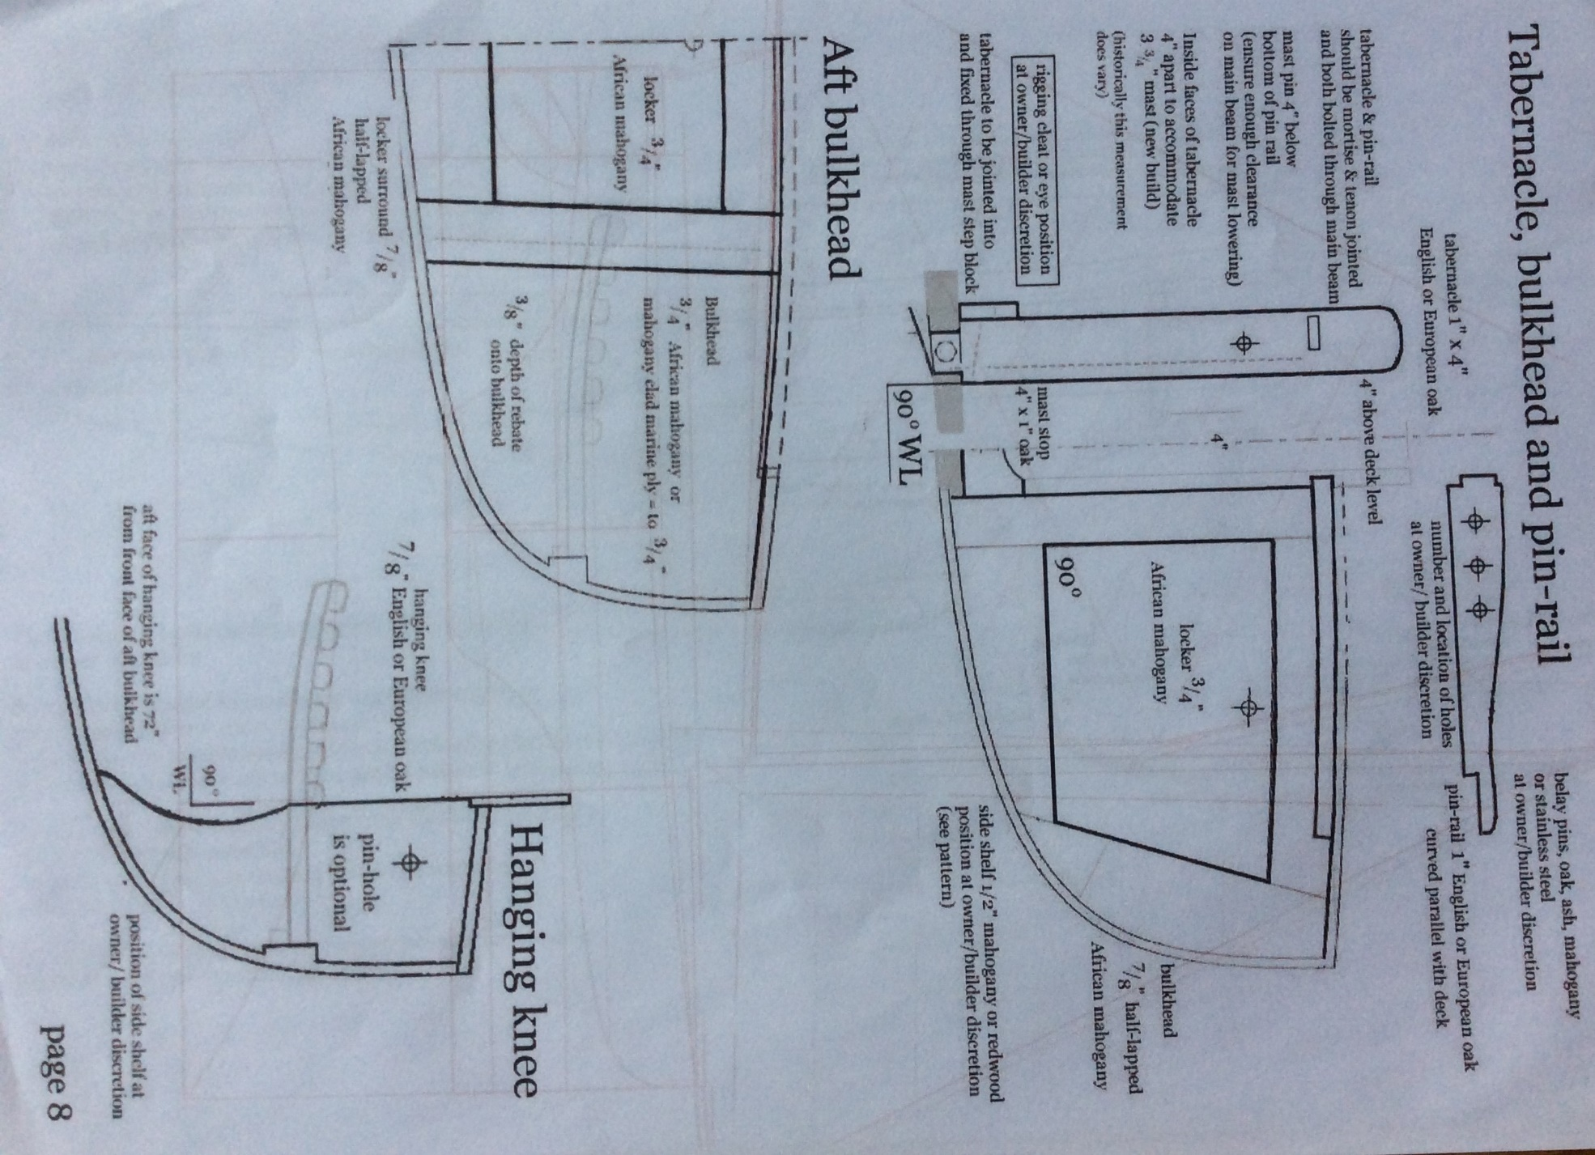

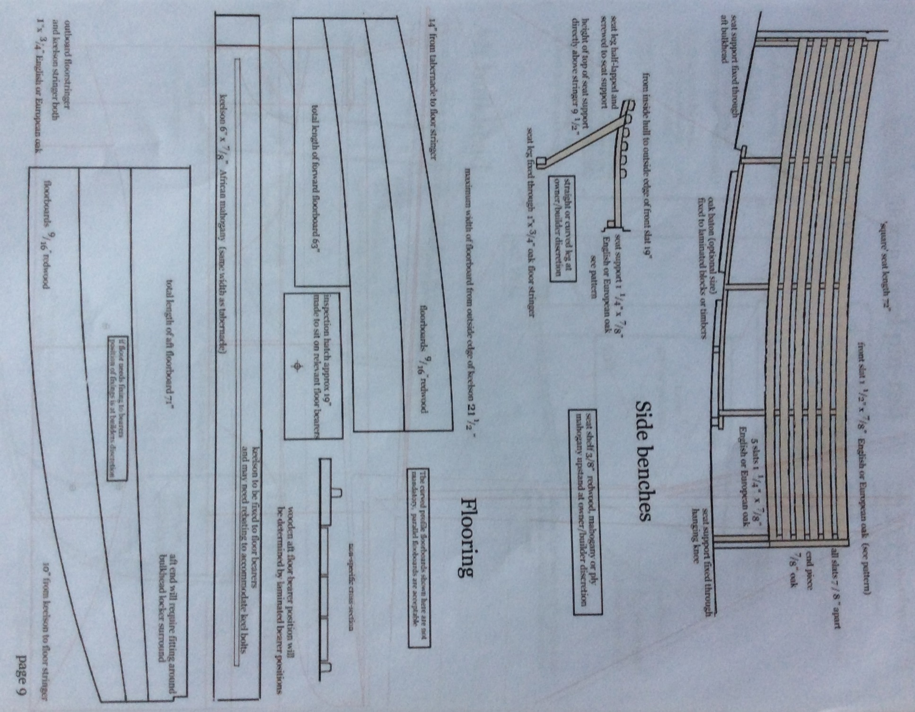

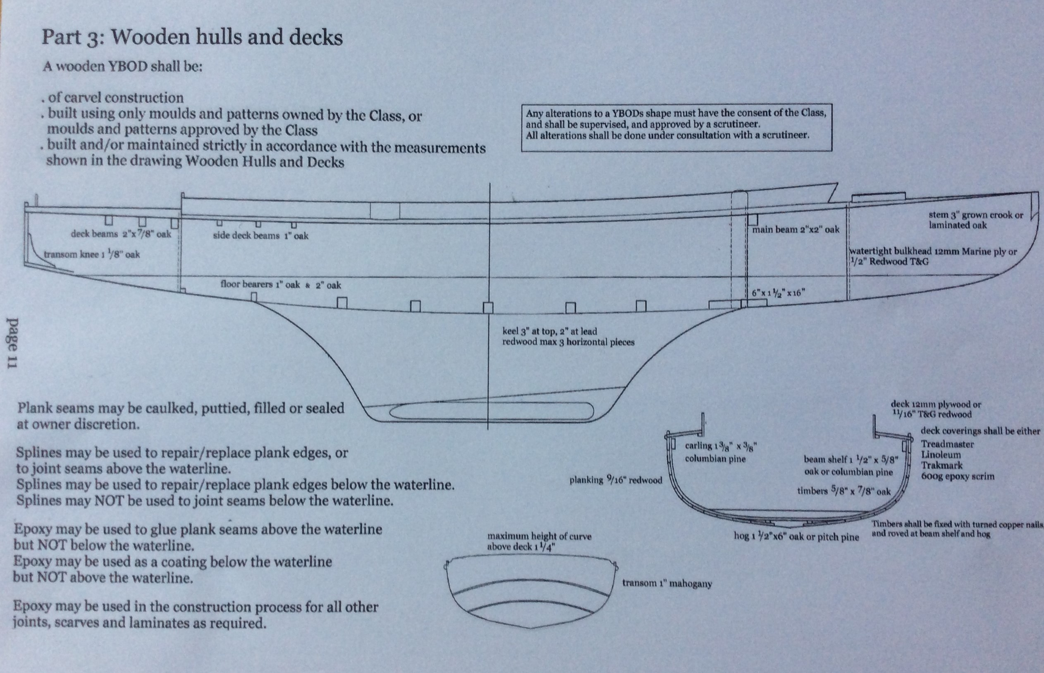

Part 4: GRP hulls and decks
- A GRP YBOD shall only be built in accordance with the Rules in Part 4 GRP hulls and decks
using the moulds owned by the class, and by a moulder approved by the class.
- The Moulding Weight of a GRP YBOD built after 1st October 2010 shall be 250kg + or -5kg
- The Complete Hull weight of a GRP YBOD built after 1st January 2004 shall be 600kg
- The Complete Hull weight of a YBOD built after 1st October 2010. which is below the 600kg Rule shall be brought within the Rules by permanently fixing 2 lead corrector weights on the boats centreline, 50% of the required weight immediately aft of the rudder tube, and 50% of the required weight in the forepeak, abutting the watertight bulkhead.
- A GRP YBOD built before 1st October 2010 with corrector weights in locations other than those stipulated in Rule 4 above, may, subject to scrutineering relocate its corrector weights to comply with Rule 4.
Hull:
To consist of a GRP lay-up consisting of: the gel coat, 2550g/sq m (8.5oz/sq.ft) chopped strand mat.
From the stem all along the centre line the lay-up to be doubled to 5100g/sq.m (17oz/sq.ft) extending 180mm each side of the centreline and further increased to 6000g/sq.m (20oz/sq.ft) above the keel.
Pine sole bearers to be over bonded with 1200g/sq.m (4oz/sq.ft) chopped strand mat
50mm flanges to be formed in way of the bulkheads from a laminate of 2400g/sq m (8oz/sq.ft) chopped strand mat.
The exterior of the hull below the waterline may be treated with a proprietary anti-osmosis treatment.
Decks:
Impregnated resin
To consist of a sandwich made up of:
a gel coat, 1200g/sq m (4oz/sq.ft) chopped strand mat
12mm end grain balsa core, 900g/sq m (3oz/sq.ft) chopped strand mat
With core to be replaced with 12mm BS 1088 plywood in way of all deck fittings and omitted at the edges of the deck in the way of the hull deck connection.
Bulkheads:
The forward bulkhead to consist of a sandwich (glassed in with 50mm. flanges from both sides) consisting of;
gel coat (installed facing aft), 900g/sq.m (3oz/sq.ft) chopped strand mat an "H" shaped core of 12mm foam (the "H" installed vertically) 600g/sq.m (2oz/sq.ft) chopped strand mat
Complete Hull
Means a complete YBOD but excluding mast, gaff, boom, sails and all associated rigging.
Moulding Weight
Means the weight (rounded down to the nearest kilogramme) of the hull and deck moulding, trimmed and bonded together, complete with; forward watertight bulkhead, main beam, floor bearers, flanges for forward and aft bulkheads, flanges for hanging knees tabernacle block, seat supports, (all bonded to hull and/or deck as appropriate) and a flo-coat finish inside of hull.

- Colours

Freeboard shall always be finished in white, whether wood or GRP,
and shall have a clear varnished transom.

Cove lines are not mandatory and may be coloured at owner discretion.

All visible woodwork shall be finished in clear varnish.

Non-visible woodwork may be finished at owner discretion.

Decks shall be off-white, cream, beige, grey or brown.

Antifouling colours shall be red, blue, black, green or 'copper'.

A bootline is not permitted.

The interior of a GRP hull shall be cream.
Colours listed above are regarded as 'traditional', if you require a different colour
please consult a scrutineer.

The boats name shall be finished in upper case gold leaf with black shading.
Said name shall be that of a British butterfly or moth taken from the
'Checklist of the British Lepidopteria' and must be approved by the Committee.

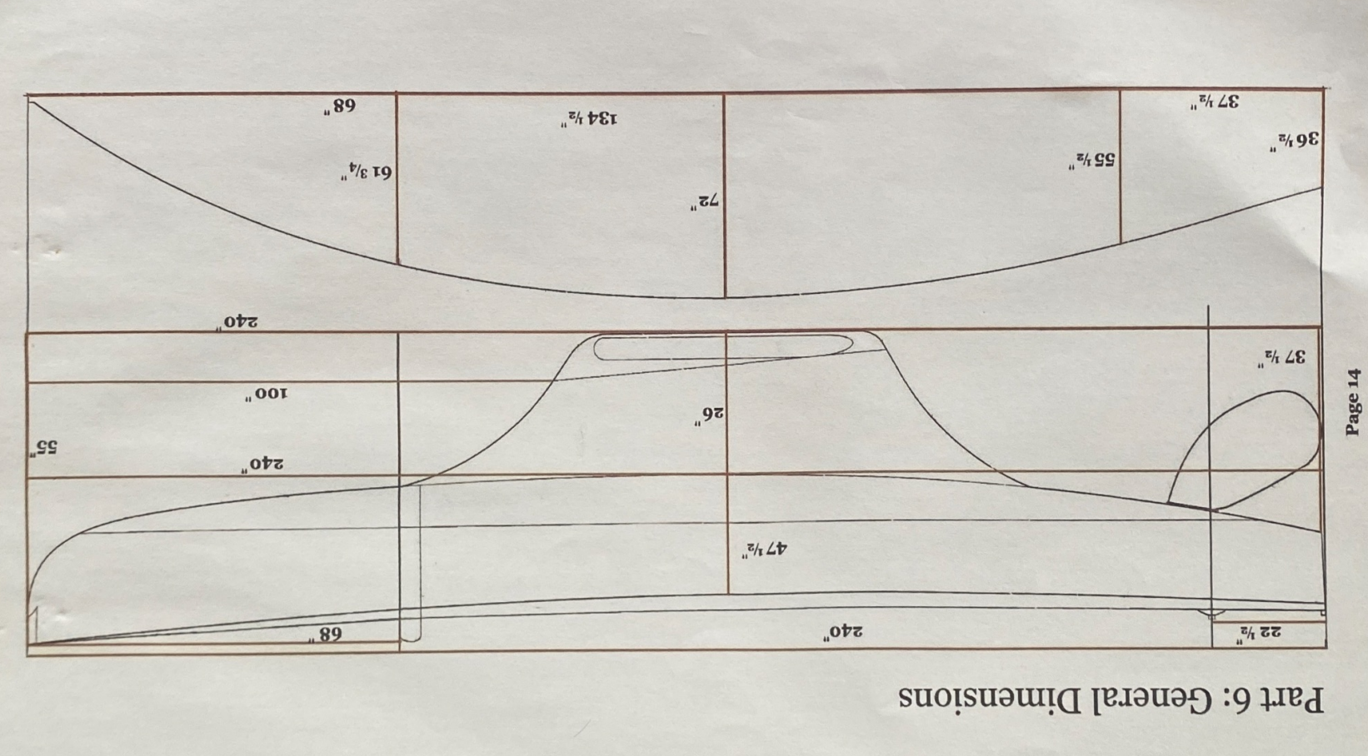
6. Scrutineering
A Scrutineer may at his discretion or at the direction of the Committee require any YBOD
to be inspected and/or measured and or weighed to ascertain whether it is in
compliance with the Rules.

A Scrutineer shall be consulted to advise on any rebuild/refit or restoration of a YBOD.

Different boatyards and builders have affected the overall 'one design' very little,
but a halt in production for two World Wars, a transition from wood to GRP
and (in some cases) more than a hundred years of repair and replacement,
have inevitably introduced some discrepancies, the scrutineering checks are
designed to keep such discrepancies to a minimum.

These checks are carried out using the following guidelines;

Any Yare & Bure One Design to be categorized as such must have 'provenance'.
It must have a year and location of build or launch, a recognized name, number or sail number, and (if possible) a credible history of past ownership etc. which could be traced back to its origins.
Said vessel must, in whole (or at least in the main part) conform to the measurements laid down in the 'Yare & Bure One Design Class Rules'.
Keel and rudder should align with the class patterns with some degree of accuracy.
The sails of said vessel must conform to the sail plan of the class sail-maker.

To be eligible for class racing a YBOD must also;

Be maintained in accordance with the rules,
Use only fittings and equipment permitted by the rules,
Carry all mandatory items listed in the rules,
Follow the 48 hour rule.

Should any YBOD fall outside the Rules, an exemption may be granted under the following circumstances.

If the discrepancy is or appears to be original, or is a direct unaltered copy of an original.
If the discrepancy is the result of a temporary repair or replacement.
If the discrepancy has previously been scrutineered and accepted by the class.

Any exemption must be approved by 2 Scrutineers

In all cases an exemption will only be granted if the said rule/measurement infringement gives no competitive advantage.

In all cases the exemption shall be considered temporary and must be
scrutineered and re-approved at pre-designated intervals.

